PROSPECTIUNI SA
1 Caransebes street, sector 1, 012271 Bucharest
Tel: 319.66.08; Fax: 319.66.56;
E-mail: office@prospectiuni.ro; www.prospectiuni.ro
A RELIABLE PARTNER !

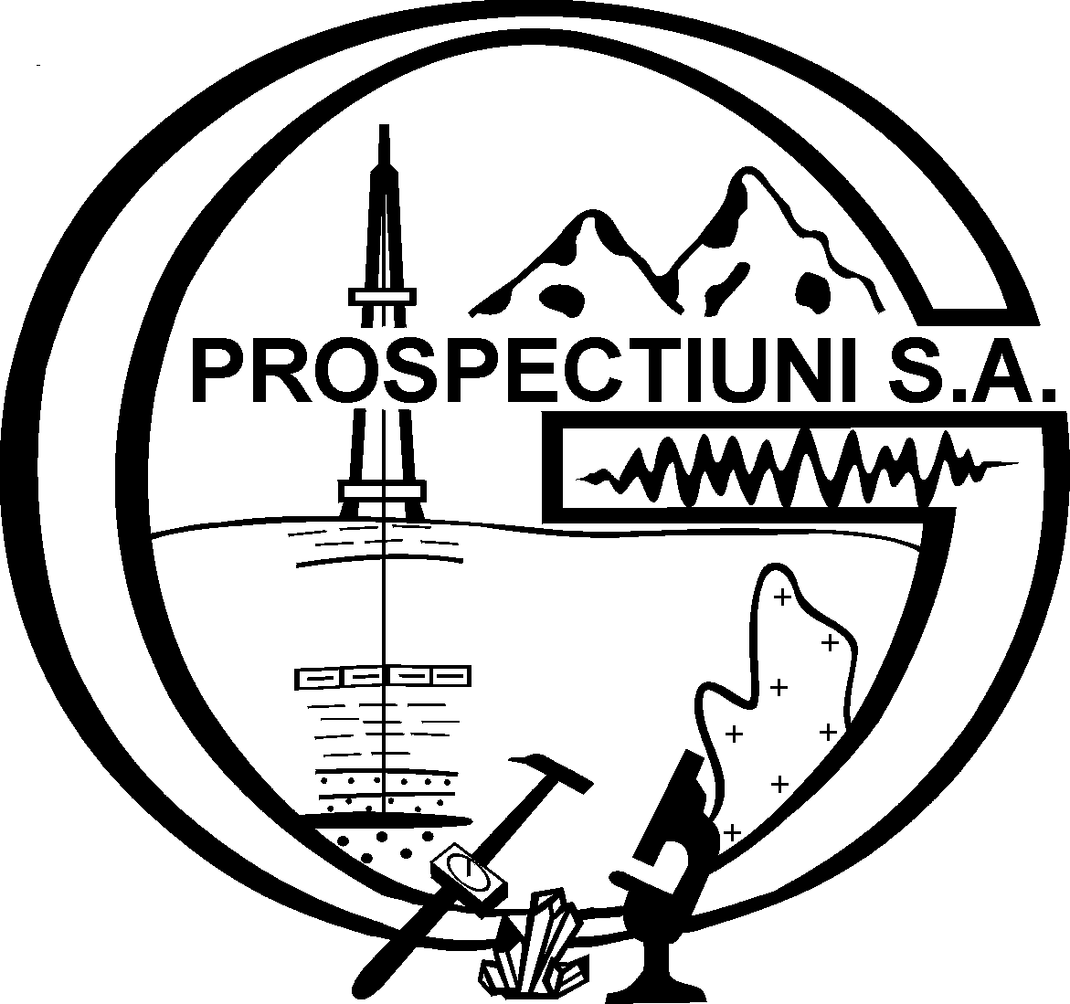

Prospectiuni S.A. Bucharest, a private joint-stock company, has more than 55 years of experience in the field of geological and geophysical research.

Prospectiuni performs:

- Seismic, gravity, magnetic, magnetotelluric and geochemical research for oil and gas ;
- Geological, geochemical and geophysical prospecting for minerals;
- Hydrogeological, geochemical and geophysical prospecting for underground, mineral water;
- Survey and geodethical works;
- Geotechnical projects;
- Physical, chemical, mineralogical and petrographical analysis;
- Environmental studies and documentations.

Contribution:

- Discovery of productive structures, oil and gas deposits in Romania, onshore and offshore, Black Sea continental platform;
- Discovery of coals, ferrous, gold – silver, bauxite, salt, minerals, industrial or ornamental rocks, underground water etc..

Main clients:

- OMV - SC Petrom SA
- National Company of Gas Romgaz SA
- Ramco Oil Plc., Falcon Romania, Aurelian Oil & Gas SRL
- Sterling Resources Ltd.
- Regal Petroleum Romania SRL
- Toreador Resources Corporation
- Cooperation with the University from Karlsruhe and Amsterdam, C.G.G., Western and Geco Prakla, University of California

Prospectiuni SA owns the adequate professional and technical equipment, last generation, to meet high quality requirements for various activities.

PROSPECTIUNI S.A. has more than 55 years of experience in the field of geological and geophysical research. The specialized departments of PROSPECTIUNI S.A. performe geophysical, geological, geochemical, hydrogeological, geo-technical prospecting for hydrocarbon, water and minerals.
On the basis of the excellent results, the National Agency for Mineral Resources certifies the capability of PROSPECTIUNI to perform geophysical and geological research of any kind. Considering the technical and economic performances of the company, the Chamber of Trade and Industry in Bucharest included PROSPECTIUNI S.A. in “Leaders in the Romanian Economy” catalogue and was awarded with the third place in “National Top of the Private Companies 2005” in it’s field of activity by C.N.I.P.M.M.R.
As soon as PROSPECTIUNI S.A. became a private company, the managerial team started a program of modernization and updating. The up-to-date equipment, which meets the highest international standards, enables PROSPECTIUNI to provide various services and to increase the efficiency of the production process.The implementation of 3D technology for seismic data acquisition and processing entitles the company to be one of the most powerful companies in this domain, at national and international level.
PROSPECTIUNI S.A. is certified ISO 9001:2001. Geological Analyses Laboratory is certified by RENAR – with Certificate 075 - L.

Company is specialized for services in the following domains:

A. Geological and Geophysical services for hydrocarbon surveys

In over 55 years of activity, the specialists at PROSPECTIUNI S.A. achieved:
  - Over 300 000 km of 2D seismic data acquisition in Romania.
  - Over 5 000 km of 2D seismic prospecting abroad.

PROSPECTIUNI S.A. contributed to the discovery of over 350 productive structures in Romania.

Performed services:

2D & 3D Seismic Modelling and Design

Geophysicists experienced in seismic data acquisition, processing and interpretation use MESA software for modelling and design of the new 2D and 3D acquisition.
The detailed geological and geophysical analysis of the work sites leads to the most adequate geometrical parameters of acquisition, in order to assure the geological objective fulfilment.

2D & 3D Seismic Data Acquisition Services

PROSPECTIUNI S.A. is able to provide six seismic crews fully equipped for 2D and/or 3D works.
- Survey: total station Leica TC 805, TC 705, GPS 1230 and 500, GPS in real time SR 530;
- Software: Ski-Pro and GPSeismic;
- Seismic drilling: drilling rigs mounted on trucks and portable;
- Recording:
  - digital recording systems: I/O System II, Image System, Sercel 428, 408 and 388;
  - 15 000 channels available for 2D and/or 3D seismic works;
  - shooting system SHOTPRO Pelton with GPS incorporated;
  - two sets of 5 vibrators AHV –IV-362 I/O and Nomad 65 Sercel;
  - each seismic crew is equipped with a system of Quality control, using ProMAX software on SUN platform.

Seismic Data Processing

The Processing department geophysicists use software of latest generation – 2D/3D ProMAX, running on different hardware facilities, network connected 2 systems IBM Cluster with 128 knots with 14 Terra Bytes external memory, Silicon Graphic’s 3200 Origin.

Seismic Data Interpretation

PROSPECTIUNI S.A. has a rich geological experience in seismic data interpretation, performing maps at different levels, tectonic and stratigraphic studies, and new-field wildcat well projects. PROSPECTIUNI S.A. has carried out and preserved a large Romanian seismic and well data base for the National Agency for Mineral Resources.

B. Geological and geophysical services for mineral resources and underground water:

Performed Services:

Geological and geo-chemical prospecting
- Geological and geo-chemical prospecting for coals, ores, minerals, industrial and ornamental rocks, peat, mineral, drinking and industrial water.
- Maintaining the geological databases.
- The digital geological mapping.
- Technical – economic documentation for exploration license.
- Technical – economic documentation for exploitation permit and license.
- Geological expertise regarding reserve/resources documentation.

Software: Encom Discover 5.0, Chimera DPA, Chimera QA/QC, MapInfo Professional 7.0 and 7.8, Surfer 8, Adobe Acrobat 6.0 Prof, Adobe Ohotoshop CS - CE

Impact studies over the environment for different activities and environmental monitoring.

Hydrogeological and geotechnical research: prospecting works through outcroping, drillings, light mining works, survey layout; exploration works through mining works, drillings, survey layout for underground water, mineral and geo-thermal water, rocks and exploitation for underground water, technical documentation for prospecting permit, exploration and exploitation license.
Equipment: Teredo DC 2000 drilling rig continuos coring, introducing core drill, semi-mechanical drilling rigs in dried system with Φ>6^{5/8”}, mechanical drilling rigs with direct circulation.

Gravity prospecting and gravity measurements on the surface and underground for outlining structures favorable to mineral and hydrocarbon accumulation.

Magnetic prospecting in igneous and metamorphic rocks for ferrous, gold-silver and base metal ores.

Magnetotelluric prospecting for hydrocarbon, especially in complex tectonics.

Electric and electromagnetic prospecting for gold – silver ores, non-ferrous, ferrous, bauxite, industrial rocks, energy resources (coal, hydrocarbon, thermal water).

Equipment:
- Survey works: Leica Total Station
- Magnetotelluric prospecting:MTU V5 System 2000 Units
- Gravity prospecting: La Coste & Romberg Gravimeter
- Magnetic prospecting: Geometrics G856AX Magnetometer
- Electric Prospecting: (Resistivity + Induced polarity) IRIS Elrec Pro

Software:
Autodesk Map 3D 2007, Autodesk Civil 3D 2007, Autodesk Raster Design 2007 Golden Software Surfer 8, WinGLink 2.18.02, MapInfo 7.8, Oasis Montaj 6.4, GM SYS 4.10.65, GP Seismic, GravMaster + GravModeler, Leica Survey Office, MagLog

C. Laboratory analyses

- WORK FIELD
  - CHEMICAL ANALYSES on: rocks (silicates, oxides, carbonates, base metals, precious metals minerals (Au, Ag, Pt, Pd and Rh), salts (NaCl, KCl, gypsum etc.), alloys, drinking, mineral, surface, underground, waste waters; coals, ashes, natural and permanent gases, bitumen, refractory materials, building materials, Pollutes from waters and soils
  - PETROPHYSICAL tests on: minerals, rocks
  - PHYSICAL-MECHANICAL Tests on: rocks, minerals, building materials, refractory materials; natural and artificial aggregates
  - MINERALOGICAL AND PETROGRAPHICAL
  - PALEONTOLOGICAL
  - GEOCHRONOLOGICAL analyses on: bulk rock, minerals

- EQUIPMENTS
- CHEMICAL Analyses: ICP-MS spectrometer, ICP-OS spectrometer,

- AAS-Flame, cold vapours and furnace spectrophotometers, Gas – chromatograph, UV-VIS Spectrophotometers, Emission Spectrometer, Gamma Spectrometer for natural radioactivity, X - Ray fluorescence spectrometer (XRF), pH-meter, conductivity meters
- PHYSICAL-MECHANICAL: Edometer, Los Angeles Equipment, Micro-Deval Equipment, Fopple Hammer, Screen Set, Grinder, Leucometer KZJ
- MINERALOGICAL AND PETROGRAPHICAL Analyses: microscopes, X rays diffraction spectrometer (DRX), Differential thermal analyser (DTA)
- PALEONTOLOGICAL Analyses: microscopes
- GEOCHRONOLOGICAL Analyses (Rb-Sr): Mass spectrometry – Rb-Sr method with isotopic dilution

International Prestiges

PROSPECTIUNI S.A. performs the main part of the geological and the geophysical works required by national and international companies: Economy and Trade Ministry, Environment and Water Administration Ministry, OMV – Petrom SA, SNGN Romgaz SA, Rompetrol SA, Arcom S.A., Gold Discovery, Allpe International, Lafarge Romcim, Shell, Hemco, Forest Oil plc., Sterling Resources plc., Aurelian Oil&Gas (Falcon), Tullow Oil plc., Wintershall AG, Regal Petroleum, Amsterdam University, Petrom Kazakstan, BRGM, Crosco etc.

