The National Institute for Earth Physics (NIEP, http://www.infp.ro) is the leading institution for seismology in Romania, responsible for the earthquake monitoring of the territory and basic and applied researches in seismology. It was established in 1977 as an organization for research and development in Earth sciences. Now is coordinated by the Romanian Ministry for Education and Research, being mainly financed by contracts from public sources. Structure of the NIEP is 6 departments, 34 researchers (18 PhD), 56 technical people and 16 PhD students.

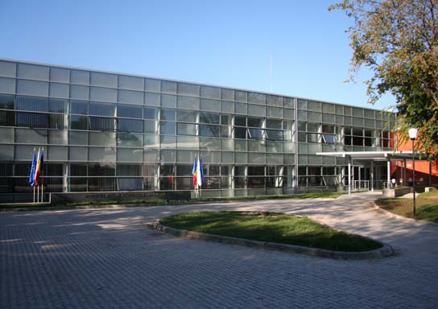

As main task, NIEP carries out the seismic survey of Romania and operates the national seismic network. It has a wide background in Earth sciences research (Earth physics), with focus on seismic source and seismotectonics; seismic hazard assessment, site effects and microzonation, engineering seismology, nonlinear seismology, lithosphere structure and dynamics; assessment and mitigation of seismic risk, seismic site studies for Cernavoda (Romania) and Beleene (Bulgaria) Nuclear Power Plants etc. Last time, NIEP made updating of the geological, geophysical, seismotectonic, seismic and soil dynamic data to obtain the final assessment of the seismic hazard at the NPP Cernavoda (Romania) site, new appraisement requested by International Agency of Atomic Energy from Vienna. Cernavoda Nuclear Power Plant seismic site studies were made by NIEP by using CANDU-Canada methodology and last PSHA-USA one, that are:

- Definition of seismic sources which can affect NPP;
- Seismic sources geometry;
- Assessment of the earthquake catalogue for each seismic sources;
- Determination of seismic activity;
- Maximum possible magnitude, including the controlling earthquake in deterministic approach;
- Probability distribution of focal depth;
- Magnitude-frequency recurrence law (in probabilistic approach);
- Assessment of uncertainties on the recurrence relationship evaluation;
- Focal distance - magnitude correlation;
- Attenuation laws (ground motions);
- Probability to exceed the acceleration, velocity or displacements (probabilistic approach) or fixed peak acceleration or other ground motion measures (deterministic approach);
- Design response spectra, computed accelerograms at surface in free field etc.

Also, NIEP has long experience in regional and global seismic studies and ensures Romania’s technical contribution to global seismological monitoring in support of the Comprehensive Nuclear-Test-Ban Treaty (CTBT). Given its demanding operational mission, key objective of NIEP is the development of an advanced seismic data collection and management system, including robust real-time data acquisition techniques, reliable communications links, rapid processing and exchange of earthquake information, creating and handling of large data sets, compilation of bulletins and earthquake catalogues.

Seismic Monitoring

NIEP operates the national seismic network, consisting of 21 stations connected in real time and 46 free-field strong ground motion K2 seismic stations (Figure 1). Continuous digital acquisition of the seismological data has been carried out since 1991. The real-time seismic network has 9 stations equipped with short-period seismometers, 11 broadband stations, one seismic array of 5 km aperture with 10 stations. The data are collected and transmitted in real time to the National Data Center in Bucharest which is integrated in the European virtual network.
The K2-network has been installed recently (starting with 1996 and continuously extended after), in the framework of the Romanian-German cooperation, within the project “Strong Earthquakes: A Challenge for Geosciences and Civil Engineering” of the University of Karlsruhe, Germany. The network covers an area with a diameter of up to 500 km centered around the Vrancea seismic zone. Another area of interest is Bucharest and its surroundings (16 of the K2 stations are installed here). The K2 stations are equipped with both accelerometer sensors (EpiSensor) and velocity sensors (broadband - KS2000, CMG3ESP and CMG40T or short period - MP, SH-1, S13). The K2 network works in trigger mode and uses 200 Hz sampling frequency.

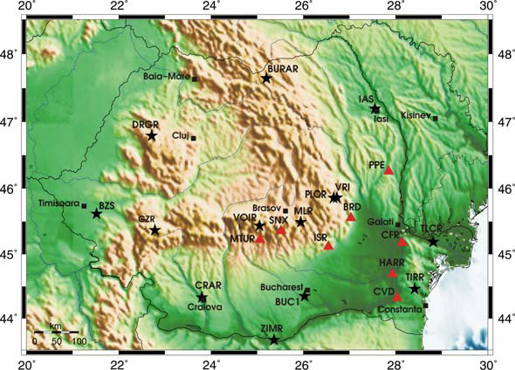
Fig. 1 − Romanian Seismic Network
(red triangles − the Romanian telemetry network, black star – digital broad band).

Data collection and exchange

Romanian data center, located in NIEP in Bucharest, collects seismic data from all stations of the real-time national seismic network and from several stations in other countries: Bulgaria (VTS - MN), Czech Republic (MORC – GE, VRAC - CZ), Greece (APE - GE), Hungary (PSZ – GE, PKSM - HU), Italy (AQU - MN), Russia (KIV – IRIS/II) and Turkey (ANTO – IU, MALT – GE, ISP - GE) (Fig. 2).

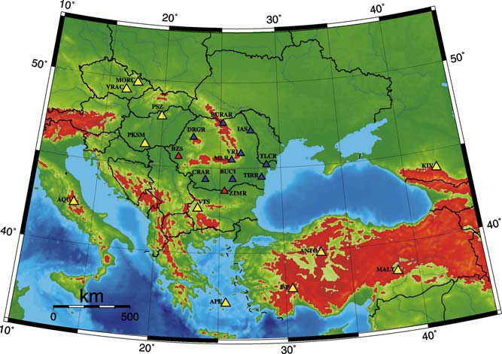
Fig. 2 – Seismic stations which are sending data in real-time to data center in Bucharest. Red triangles indicate future real-time stations of the national network.

Data from the national seismic network are collected in real-time using SeisComP/SeedLink and Antelope 4.8 software. The data are exchanged with all the institutions which supply data to the national data center in Bucharest using SeedLink-SeedLink and ORB-ORB connections. Fig. 3 shows the data flow between the data center in Bucharest, seismic stations of the national networks and other institutions.

National and international projects

NIEP is currently coordinating 37 national projects within CERES (29 projects), MENER (6 projects) and CORINT (2 projects) Programmes funded by the Romanian Ministry of Education and Research.

During the last years, NIEP has been actively involved in many international programs, as world-wide interdisciplinary research programs, regional projects or national programs on seismic hazard and risk. In the framework of such projects, NIEP successfully cooperates with many scientific organizations around the world.

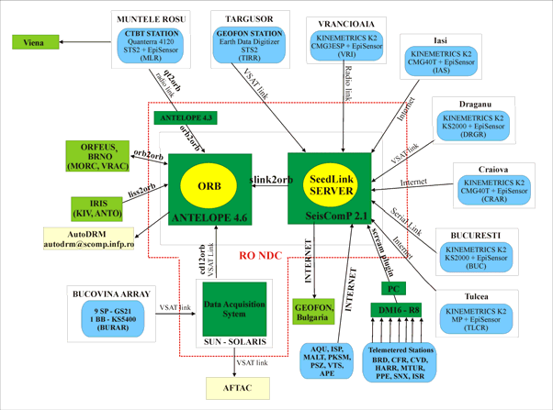
Fig. 3 p – Data flow between the data center in Bucharest, national seismic stations and other institutions.

Relevant international projects are:

- NATO SfP 972266 - ‘Impact of Vrancea Earthquakes on the Security of Bucharest and other Adjacent Urban Areas’;
- UNESCO IGCP 414- ‘Realistic Modelling of Seismic Input for Megacities and Large Urban Areas’;
- Seismic verification in support of CTBT, IDC Vienna;
- “Assessment of Seismic Potential in European Large Earthquake Areas”, COPERNICUS Project;
- “Mediterranean European Rapid Earthquakes Data Information and Archiving Network”, European Commission Project, contract no. EVR1-CT-2000-40007;
- “Novel Optical Devices and Techniques for Seismic Activity Detection and Measurement”, European Commission Project, contract no. ECG1-CT-2002-00062;
- “The Central European Regional Geodynamics Project”, CERGOP;
- ”3D monitoring of active tectonic structures”, COST 625 Project.
- “Network of Research Infrastructures for European Seismology” (NERIES), FP 6 Project, FP6-2004-Infrastructares-S, Proposal No. 026130;
- „Seismic Early Warning for Europe” (SAFER), FP 6 Project, FP6-2005-GlOBAL-4, Proposal No.036935.

as well as bilateral co-operation programmes with:

- University of Karlsruhe, Germany – ‘Strong Earthquakes: a Challenge for Geosciences and Civil Engineering’, CRC461 Programme;
- University of Trieste, Italy - ‘Microzonation of Bucharest’;
- GeoForschungsZentrum Potsdam, Germany - ‘Task Force Earthquakes’;
- AFTAC, USA - ‘Seismic Monitoring Array in Romania’;
- JICA, Japan - ‘Technical Cooperation Project for a Seismic Monitoring Station in Romania’;
- “Seismic Attenuation and Anisotropy in the Carpathians and Adjacent Basins: Upper Mantle Role in the Last Stages of Tethyan Closure”, National Scientific Foundation Project EAR-0230336, Univ. North Caroline, USA.
- Institute of Geophysics, ETH Hoenggerberg, Zuerich, Switzerland - “CALIXTO - Seismic Tomography in the Vrancea Region, Romania”, Project SCOPES, nr. 7SUPJ062404.

