Situation and perspectives in investigations of recent Earth’s crust geodynamics in the Ukrainian Carpathians

Maksymchuk V.¹, Tretyak K.², Kuznetsova V.¹

¹ Carpathian branch of S.I.Subbotins Institute of Geophysics, National Academy of Sciences of Ukraine. Naukova Str., 3-B, Lviv 79060 Ukraine, vmaksymchuk@cb-igph.lviv.ua , depart10@cb-igph.lviv.ua
² National University “Lviv Polytecnic”, Institute of Geodesy, S.Bandera str., 12, Lviv 79046 Ukraine kornel@polynet.lviv.ua

Abstract

Investigations of Earth’s crust recent geodynamics in the Ukrainian Carpathians are fulfilling more than last 40 years and are aimed on studying of general patterns of recent movements of Earth’s crust, its seismicity, geophysical fields variations, definition of reasons and mechanisms of recent seismic-tectonic processes and solution of global tectonic-genesis origin. For such aims since 1965 in the Ukrainian Carpathians by means of scientific organizations of the Ukrainian Academy of Sciences and Ministry of Education of Ukraine was founded the Carpathian geodynamic polygon (see figure). The polygon is located in the SW part of the Ukrainian Carpathians and Transcarpathian inner trough: Polonyna zone of, Transcarpathian trough, Vihorlat-Hutin volcanic ridge, Transcarpathian (Pienin) and Pannonian deep faults.
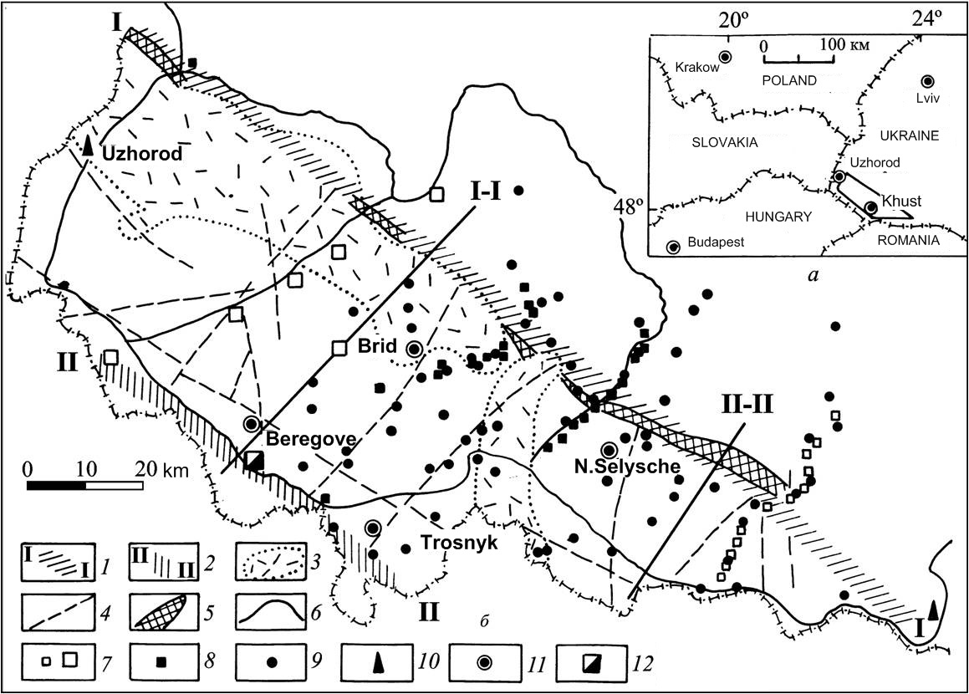

The Carpathian geodynamic polygon:
1 – Transcarpathian deep fault; 2 – Pannonian deep fault; 3 - Vihorlat-Hutin volcanic ridge; 4 – faults of Carpathian backdeep’s pre-Neogene basement; 5 – Pienine zone; 6 – lines of repetitive leveling; 7 – secular multi-purpose reference points; 8 – reference points for complex (geomagnetic and geodetic) observations; 9 – geomagnetic repeat points; 10 – seismic stations; 11 – regime geophysical stations; 12 – tension-metering station

Transcarpathians is one of the most active seismic zones in the Ukrainian Carpathians. Its seismicity is characterized by earthquakes with sources in the Eastern Carpathians in Ukraine, on adjusted territories – Poland, Slovakia, Hungary and Romania. More – Transcarpathians are under an influence of catastrophic earthquakes with deep focuses in Vranch zone (Romania), which can be sense here with intensity up to 4 (MSK-64 scale).
After historical and recent instrumental data during 1961 – 2009 in the Transcarpathians is known a number of powerful earthquakes, which are described not only by Ukrainian, but by foreign seismologists. Maximum macro-seismic effect from Thranscarpathian earthquakes during last 200 years is not higher 7 – 8 [1, 3].
The Carpathian seismic network yearly registers in the Transcarpathians averagely 5 – 20 earthquakes with energy class K = 6 – 10 (Rautian scale) with hypocenters mostly located in upper layers of the Earth’s crust (2 – 10 km). During instrumental observations here were fixed more than 600 events. Among them more than 300 happened in the Transcarpathians. Maximum intensity of earthquakes here is 7 points, what means K = 12 – 13 energy class.
The complex of geodynamic investigations on the Carpathian polygon in 1970 – 1980 includs:
- Studying of non-tidal variations of gravitation;
- Studying of geomagnetic field secular variations;
- Studying of vertical and horizontal Earth’s crust movements;
- Observations of tensions.
In the middle of 80th years on the polygon were founded four stationary permanent geophysical stations (PGS). On these stations micro-seismic (registration of earthquakes and micro-seismics) geomagnetic, geothermal, acoustic-seismic, electromagnetic and meteorological observations are fulfilling. This gives an opportunity for monitoring of geodynamic and seismic-tectonic processes in the Transcarpathians, investigations of local earthquakes precursors.
To study Earth’s crust deformations by direct methods in the end of 70th on the polygon, in the zone of Pannonian deep fault were founded a tension-metering station (Beregove-1). Since 1986 in the tension-metering station are fulfilling permanent tension-metering observations by means of 2 horizontal quartz tension-meters. In this tension-metering station in 1982 was located automatic system of geoacoustic parameters registration to control variations of stress-strained state of Earth’s crust. Later, in 1990 tension-metering observations were started in the same zone on the station Beregove-2, and in 1999 on the point Korolevo in the zone of the Oash fault.
To study geodynamic processes in 1977 – 1980 were founded three profiles, crossing the zone of Transcarpathian deep fault for long-term geodetic and geophysical observations: Irshava – Kushnytsia, Khust – N.Bystryj, Teresva – Ust’ Chorna.
For investigations of horizontal movements of the Earth’s surface in the Carpathian region in 1968 – 1970 was formatted spatial network on the 30 km area in the NW part of the fault and approximately 1000 sq.km of folded Carpathians and Transcarpathian trough. Lines were measured by optical range finder “Geodimeter” with the accuracy 5·10⁻⁷.
For today for definition of spatial movements and deformations of the Earth’s surface in the Carpathian region are used results of measurements, fulfilled in the permanent GPS stations of European EUREF.
The most important results for the Carpathian geodynamic polygon can be:
- Long-term series of geomagnetic data in the network of permanent geophysical stations. In temporal variations of magnetic field were investigated anomalous effects of various origin: quazi-linear trends of tectonic origin, season anomalies due to exogenous processes and episodic variations, caused by preparation of local earthquakes;
- on the base of data of permanent magnetic-variation observations were defined variations of Vize’s induction vector (Parkinson), caused by geodynamic processes in the Earth’s crust and by an influence of ionosphere effects and seismic-tectonic origin;
- was investigated a structure of tectonomagnetic anomalies and stated their connection with peculiarities of deep structure of the region;
- data about character and intensity of horizontal movements of the Earth’s crust near Trancarpathian deep fault were obtained;
- characters and intensity of crust’s vertical movements were investigated
- on the base of permanent tension-metering in rock massifs value and directions of rocks deformation in the Transcarpathian trough were evaluated; their connection with seismic-tectonic processes in the region was defined;
The most detailed results of geophysical investigations in the Ukrainian Carpathians are cited in the monographs [1, 2, 3].
Continuation of investigations in the Carpathian region (based on previous results) had to be concentrated in the following directions: seismic monitoring in the Transcarpathian seismic zone; monitoring of recent vertical and horizontal movements of Earth’s surface, based on geodetic and GPS observations; geophysical monitoring of parameters variations in the geological environment, and definition of earthquakes precursors, development of methods for their prediction; development of a network of stationary complex predicting stations in the Thranscarpathian seismic-active zone; development of new methods and technical solutions for estimations of stress-strained state of the crust; investigations of an influence of external factors on processes in the Earth’s crust; development on investigations methods to study a dynamics of tectonic displacement stresses on the base of spatial-temporal variations of geophysical fields.

References
1. The Carpathian geodynamic polygon. / ed. Podstrygach Ya., Chekunov A. – M.: Sov.radio, 1978. – 126 p. /in Russian/
2. Geodynamics of Northern Carpathians./ Editor Janusz Sledzinski. – Warsaw: Reports on geodesy. – 1998. – № 6 (36), 162 р.
3. Maksymchuk V., Kuznetsova V., Horodyskyy Yu., et al. Investigations of the recent geodynamics in Ukrainian Carpathians. – Kyiv, Naukova dumka, 2005. – 254 p. /in Ukrainian/

