Abstract template for the 4th International Volcano geology Workshop (Eastern Transylvania, Romania)

John Thyphon¹, Abigail Tephra², Gaby Veryhonest², Anna Pomanna³ and Zoltán Avalanche³

¹ Center of Volcanic Studies-CDEFB, Mandragora, Gobelinia – thyphon @abcd.edu.go
² Departament of Geological Sciences, Buenas Aquas, Argentinia
³ Volcanic Dept., Crater University, Pool North, Vulcania

Keywords: insert, three, keywords.

This template is an example of how to prepare an abstract for the 4th IVG Workshop to be held on 8-14 October 2017 (Eastern Transylvania, Romania). The simplest way to comply with the requested abstract format is to replace the text in this template with your text.
The title has to be typed in font Arial 14 pt bold.
The Authors’ names have to be typed in Arial 9 pt, with the presenting Author (either for oral or poster presentation) in boldface.
The Authors’ affiliations have to be typed in Arial 8 pt italics. The email address of the presenting Author is requested, and he/she will be referred to also as the Corresponding Author.
Three Keywords have to be supplied and typed in Arial 8 pt.
The main text has to be typed in Times New Roman 10 pt.
Black/white and color graphics/figures are allowed and welcome. Figures can be either one column-wide (7.5 cm) or two column-wide (between 7.5 and 16 cm). Any figure should be inserted in the text as a JPG file with 300 dpi resolution.
A brief paragraph with Acknowledgements may be added at the end of the main text.
A limited number of citations in the text are welcome, and the relevant list of references has to be added at the end of the abstract. The ways to cite in the text are: Amato (1832), for single-author papers; Bento and Wilson (1780), for two-author papers; Caravagio et al. (1452), if the authors are more than two. The reference format is shown in the Reference paragraph at the end of this template.
The length of the abstract cannot exceed two pages in this format. On the other hand, the Authors are strongly encouraged to submit informative abstracts longer than a single page.
The abstract should be submitted as a word file. The file size should not exceed 2 Mb in order to facilitate the upload process. Note that you should also copy the text (without figures) in the Abstract box.
The abstract has to be uploaded using the 4th IVG upload interface until 1st September 2017. Together with the abstract, the Authors have to indicate their preferred mode of presentation, either oral or poster. The Organizing Committee will allocate a limited number of oral presentations, with the remainder as posters. Thus some presentations proposed as oral by the Authors could turn to posters, while no presentations proposed as posters by the Authors will become oral presentations without permission from the Corresponding Author.

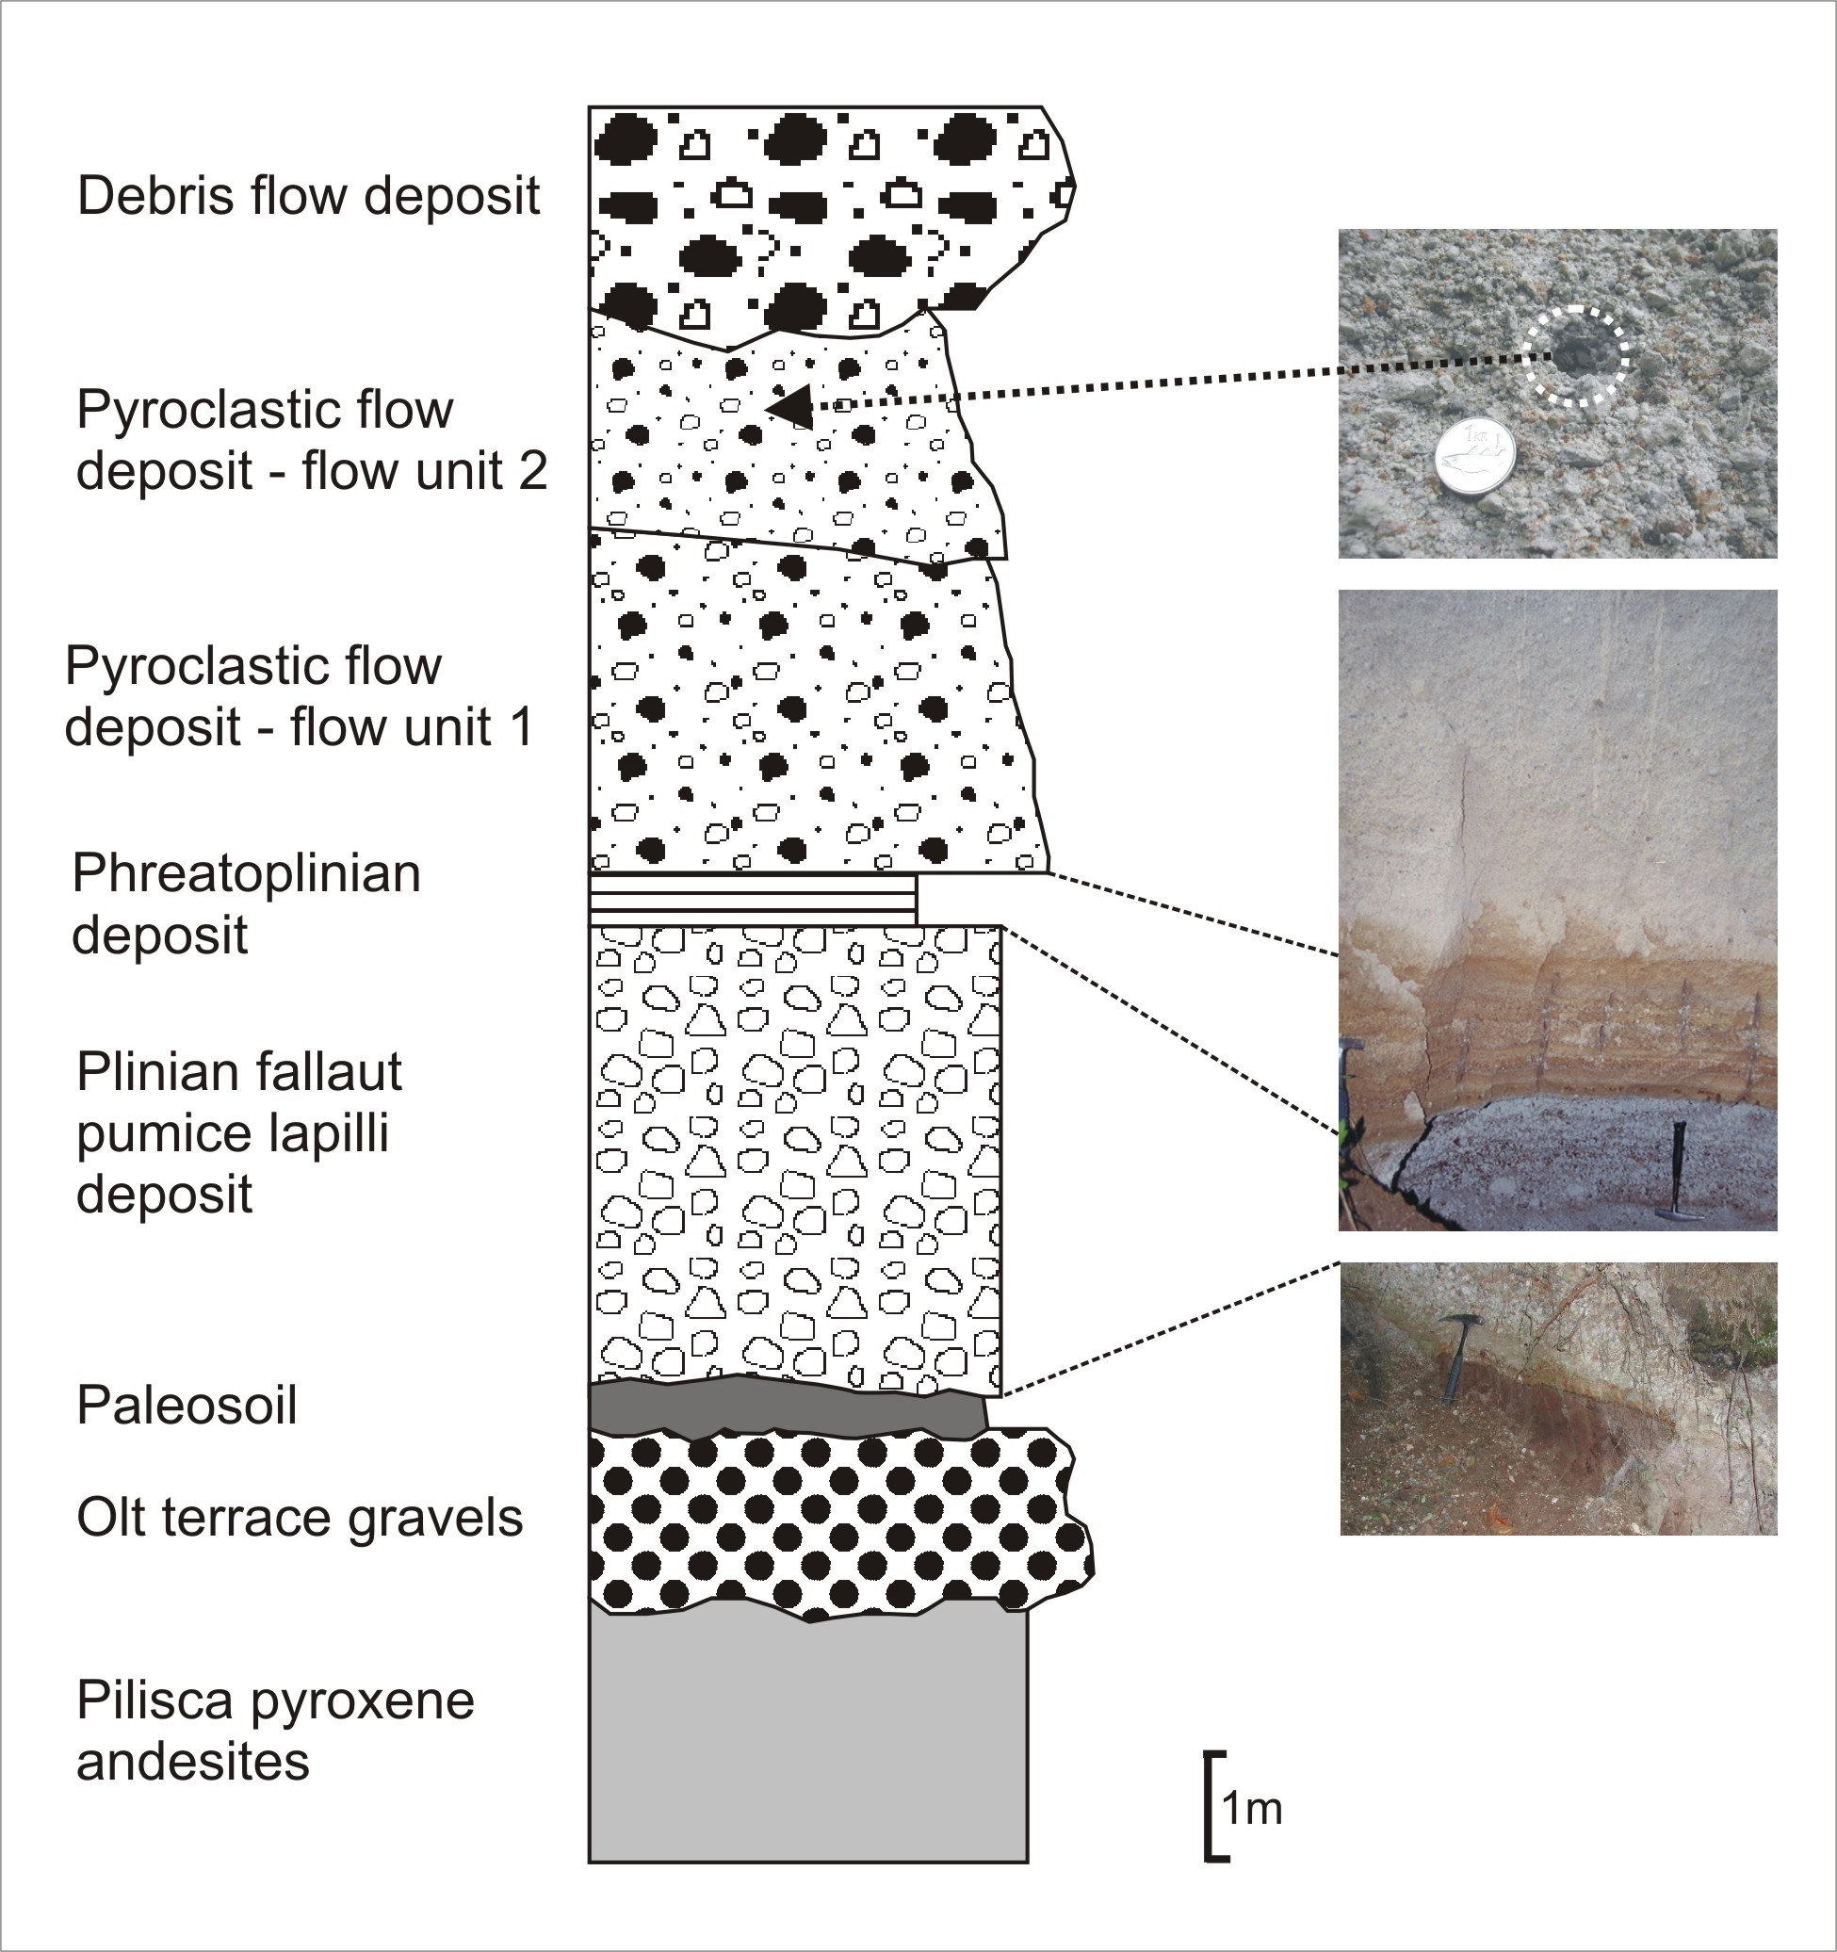
Fig. 1 – The caption(s) of the figure(s) should be typed in this format. The font to be used is Arial 8 pt.

This sentence is written just to fill the available space and contains no useful information for the abstract submission. This sentence is written just to fill the available space and contains no useful information for the abstract submission. This sentence is written just to fill the available space and contains no useful information for the abstract submission.
This sentence is written just to fill the available space and contains no useful information for the abstract submission. This sentence is written just to fill the available space and contains no useful information for the abstract submission. This sentence is written just to fill the available space and contains no useful information for the abstract submission. This sentence is written just to fill the available space and contains no useful information for the abstract submission.

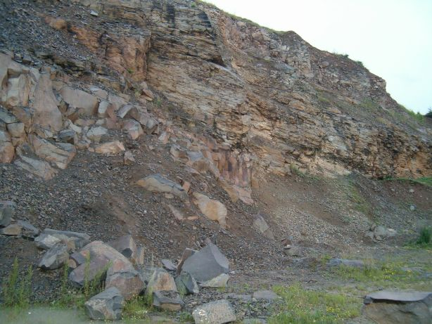
Fig. 2 – The caption(s) of the figure(s) should be typed in this format. The font to be used is Arial 8 pt.

This sentence is written just to fill the available space and contains no useful information for the abstract submission. This sentence is written just to fill the available space and contains no useful information for the abstract submission. This sentence is written just to fill the available space and contains no useful information.
This sentence is written just to fill the available space and contains no useful information for the abstract submission. This sentence is written just to fill the available space and contains no useful information for the abstract submission. This sentence is written just to fill the available space and contains no useful information for the abstract submission. This sentence is written just to fill the available space and contains no useful information for the abstract submission. This sentence is written just to fill the available space and contains no useful information for the abstract submission. This sentence is written just to fill the available space and contains no useful information for the abstract submission. This sentence is written just to fill the available space and contains no useful information for the abstract submission. This sentence is written just to fill the available space and contains no useful information for the abstract submission.
This sentence is written just to fill the available space and contains no useful information for the abstract submission. This sentence is written just to fill the available space and contains no useful information for the abstract submission.
This sentence is written just to fill the available space and contains no useful information for the abstract submission. This sentence is written just to fill the available space and contains no useful information for the abstract submission.
This sentence is written just to fill the available space and contains no useful information for the abstract submission. This sentence is written just to fill the available space and contains no useful information for the abstract submission.
This sentence is written just to fill the available space and contains no useful information for the abstract submission. This sentence is written just to fill the available space and contains no useful information for the abstract submission.
This sentence is written just to fill the available space and contains no useful information for the abstract submission. This sentence is written just to fill the available space and contains no useful information for the abstract submission.
This sentence is written just to fill the available space and contains no useful information for the abstract submission. This sentence is written just to fill the available space and contains no useful information for the abstract submission.
This sentence is written just to fill the available space and contains no useful information for the abstract submission. This sentence is written just to fill the available space and contains no useful information for the abstract submission.
This sentence is written just to fill the available space and contains no useful information for the abstract submission. This sentence is written just to fill the available space and contains no useful information for the abstract submission.

Acknowledgements

All the Authors are kindly thanked for having submitted an abstract formatted according to this template.

References

Cas R.A.F., Wright J.V., 1987. Volcanic Successions – Modern and Ancient. Allen & Unwin, London, pp 1–528
Fisher, R.V., and Schmincke, H.-U., 1984, Pyroclastic Rocks; Springer-Verlag, New York, 472 pp.
Hauer Fr., Stache G., 1863. Geologie Siebenbȕrgens. Ed. Wilhelm Braunmȕler, pp. 637, Wien.
Herbich Fr., 1878. Das Szeklerland. Jahrb. Der Kgl. Und geol. Aust, V, Budapest.
Koch A., 1900. Die Tertiärbildungen des Beckens der Siebenburgischen Landesteile. Neogen teile, Budapest.
Laţiu V., 1928. Contribution to the petrographic study of the basalt with quartz xenolith from Racoşul de Jos. An. Inst. Geol. Rom., XIII, 1-22, Bucharest (In Romanian)

